PROJECT TITLE: COMPREHENSIVE DIGITAL MARKETING FOR WOW Cosmetics

STUDENT NAME: JAGGAMPUDI SAI SRI

PROJECT SUPERVISOR: Dr.Varoodhini

DEPARTMENT: BBA

COLLEGE: SATYA INSTITUTE OF TECHNOLOGY AND MANAGEMENT

TEAM ID: LTVIP2025TMID24594

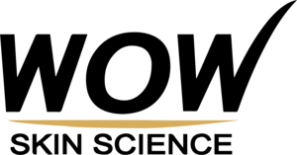

**INTRODUCTION**

WOW Skin Science is a nature-inspired beauty brand founded in 2014, known for its safe and effective skin and hair care products, free from harsh chemicals like sulfates, silicones, and parabens. They focus on natural ingredients and aim to provide solutions for various skin and hair concerns.

WOW Skin Science is a well-known skincare and haircare brandthat offers a range of natural products designed to promote healthy skin and hair. The brand emphasizes using high-quality, plant-based ingredients and avoids harmful chemicals, such as parabens, sulfates, and mineral oils, making it a popular choice among consumers seeking clean beauty products.

Some of their key offerings include shampoos, conditioners, face cleansers, body lotions, oils, and serums. Their products are often enriched with natural extracts, essential oils, and vitamins to cater to various skin and hair concerns, such as hydration, anti-aging, brightening, and nourishing.

WOW Skin Science has become a trusted name in the beauty industry due to its commitment to cruelty-free, vegan, and sustainable practices. They prioritize transparency in their formulations and ensure that their products are free from harsh additives, making them a great choice for those looking for gentle yet effective skincare and haircare solutions.

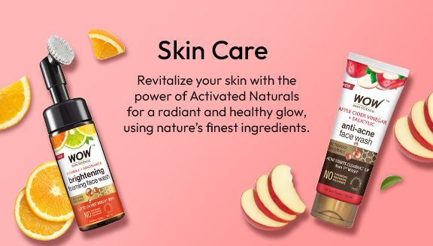

## Brand Study of Digital Marketing wow cosmetics

​WOW Skin Science, established in 2014, has emerged as a prominent Direct-to-Consumer (D2C) skincare brand in India, renowned for its natural, toxin-free products. The brand's digital marketing strategy has been pivotal in its rapid growth and strong market presence

**Target Audience and Digital Focus**

WOW Skin Science primarily targets internet-savvy millennials and Gen Z consumers. Recognizing the digital proclivities of this demographic, the brand adopted a digital-only omnichannel approach, leveraging platforms like Instagram, Facebook, and YouTube to engage and inform its audience

**Influencer Collaborations**

A cornerstone of WOW's digital strategy is influencer marketing. The brand has collaborated with a spectrum of influencers—from micro to macro—who resonate with its target audience. These influencers produce authentic content, including product reviews and tutorials, which enhances brand credibility and extends reach. 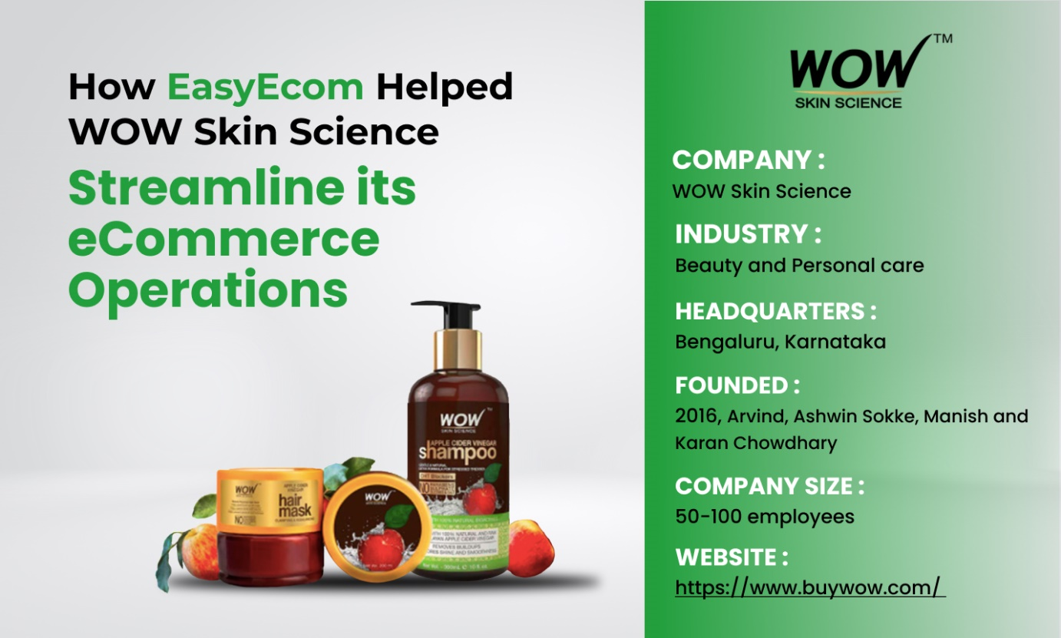​

**Performance Marketing and Advertising**

WOW Skin Science employs targeted online advertising strategies to bolster brand visibility and drive sales. This includes search engine marketing (SEM) with Google Ads and social media advertising focusing on natural hair and skincare products. The brand also utilizes search ads with extensions like site links to improve ad performance

**Content Strategy and Customer Engagement**

The brand maintains an active and engaging social media presence, sharing a mix of product promotions, user-generated content, skincare tips, and educational posts. Regular live streams with experts provide value-added content, fostering a sense of community and trust among followers.

**E-commerce Integration and Sales Channels**

WOW Skin Science has effectively integrated its digital marketing efforts with e-commerce platforms. Its products are available on its official website and app, as well as major e-commerce platforms like Amazon, Flipkart, Nykaa, Grofers, and Bigbasket. In 2020, a significant 93% of its sales in India were attributed to online channels

**Innovative Campaigns and Social Responsibility**

The brand has launched campaigns addressing current trends and social issues, such as the #TrashYourSpam initiative to combat digital pollution and eco-friendly promotions during festivals. These campaigns resonate with the eco-conscious values of their target audience, strengthening brand loyalty.

In summary, WOW Skin Science's digital marketing strategy—characterized by targeted influencer collaborations, robust online advertising, engaging content, and seamless e-commerce integration—has been instrumental in establishing its strong presence in the competitive skincare market.

**Competitor Analysis of Digital Marketing wow cosmetics**

​WOW Skin Science, a prominent player in India's personal care and wellness industry, employs a robust digital marketing strategy to maintain its competitive edge. Here's an analysis of their approach compared to key competitors like SUGAR Cosmetics and Mamaearth. 

**Digital-First Approach:** WOW Skin Science has embraced a digital-only omnichannel strategy, targeting internet-savvy millennials and Gen Z consumers. They focus on e-commerce platforms and social media channels to reach their audience effectively.

**Research Brand Identity of wow cosmetics** 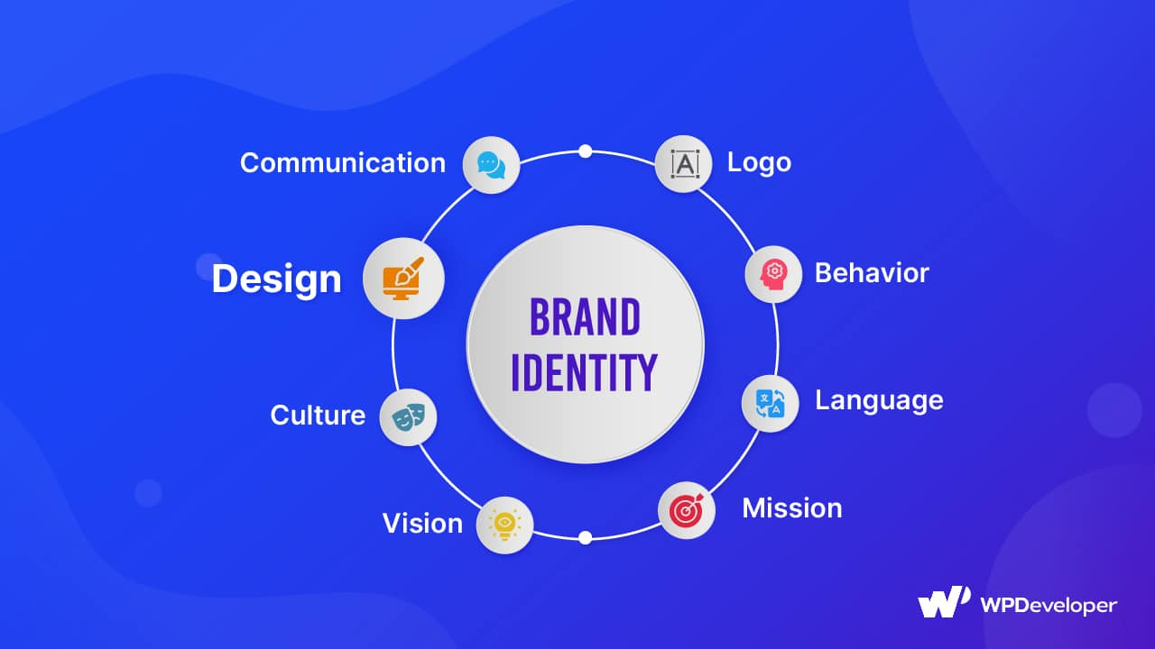

* WOW Skin Science has successfully carved a niche for itself in the competitive beauty and wellness market by focusing on natural, toxin-free products and a customer-centric approach.
* The brand's digital-first strategy and D2C model have been instrumental in reaching its target audience and building a strong online presence.
* WOW Skin Science's commitment to natural ingredients and effective formulations has resonated with consumers, leading to brand growth and recognition.

**Audience persona of wow cosmetics**

Here’s a detailed **Audience Persona** for WOW Skin Science, based on their brand positioning and marketing strategy:

1. Demographics
2. Psychographics
3. Behavioral traits

WOW Skin Science primarily targets **eco-conscious, health-focused, and socially responsible** individuals who seek **natural, effective, and sustainable personal care products.**

Their digital marketing effectively engages this audience through **influencer partnerships, user-generated content, and sustainability messaging**.

**SEO Of wow cosmetics**

**combination of natural and scientific approaches, leveraging social media** WOW Skin Science, a D2C skincare brand, has built its brand through a and e-commerce platforms to reach customers, and focusing on educating consumers about their products.

WOW Skin Science has effectively harnessed Search Engine Optimization (SEO) as a pivotal component of its digital marketing strategy to enhance online visibility and drive organic traffic.

1.Keyword Optimization

2. High-Quality Content Creation

3. Influencer Collaborations

4. User Experience Enhancement

5. Local SEO Efforts



Through these comprehensive SEO strategies, WOW Skin Science has strengthened its online presence, connecting effectively with consumers seeking natural and sustainable beauty solutions.

**Keyword Research on wow cosmetics**

Conducting keyword research for WOW Skin Science can provide valuable insights into consumer interests and enhance your digital marketing strategy. While specific search volume data for WOW Skin Science products is not readily available, here are some general categories and examples of keywords that can be beneficial

1.Product-Specific Keywords

2. Skin Concern Keywords

3. Ingredient-Focused Keywords

4. Branded vs. Non-Branded Keywords

5. Long-Tail Keywords

6.Local SEO Keywords

7.Trending Keywords

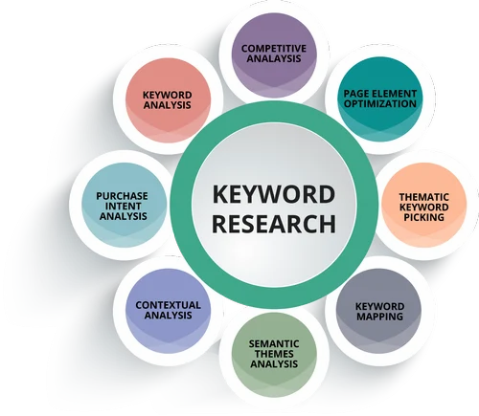

Incorporating these keywords into your website content, blog posts, and product descriptions can improve search engine visibility and attract potential customers. Regularly updating your keyword strategy based on market trends and consumer behavior is essential for maintaining a competitive edge.

**SEO On page optimization**

On-page SEO optimization involves optimizing individual web pages to rank higher in search engines and attract relevant traffic. Here’s a step-by-step guide to improve on-page SEO.

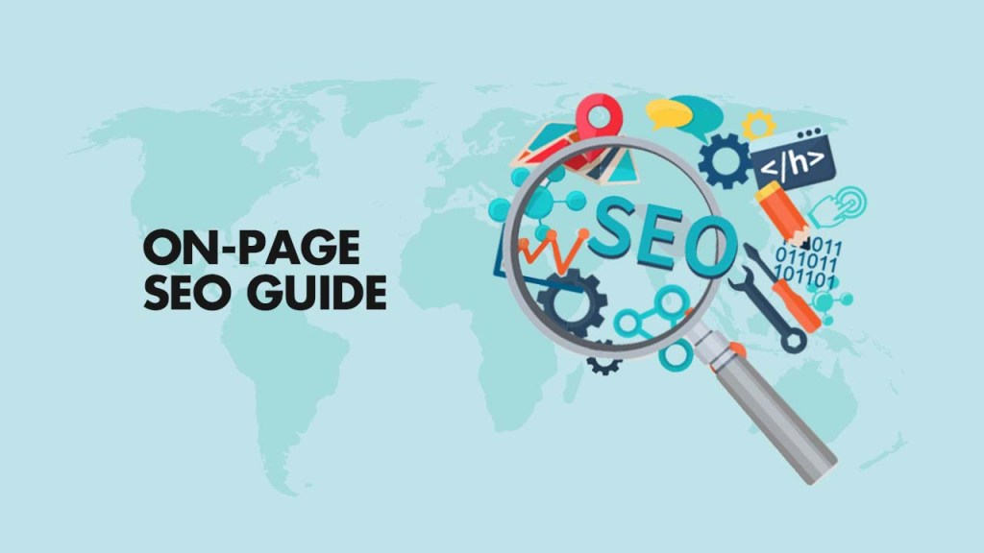

1. Keyword Optimization
2. Meta Tags Optimization
3. URL Structure
4. Header Tags (H1, H2, H3)
5. Content Optimization
6. Internal & External Linking
7. Image Optimization
8. Mobile-Friendliness
9. Page Load Speed
10. Schema Markup (Structured Data)
11. User Engagement & Experience
12. Technical SEO Considerations

By implementing these **on-page SEO** strategies, you can improve your website’s rankings and attract more organic traffic. Let me know if you need help with specific aspects!

**Content ideas of wow cosmetics**

WOW Skin Science, a nature-inspired beauty brand, focuses on content creation that educates consumers about their products, promotes sustainability, and leverages influencer marketing and social media to build brand awareness and drive sales.

Creating high-quality content for WOW Cosmetics involves a mix of **informational, promotional, and engaging** content to attract and retain customers. Here's a structured approach to developing content for WOW Cosmetics across different platforms:

1. Blog Content
2. Social Media Content
3. Video Content (YouTube & Reels)
4. Email Marketing & Newsletters
5. E-Commerce & Product Descriptions (Website & Amazon)
6. Influencer & Affiliate Marketing

**Marketing strategies of wow cosmetics**

WOW Cosmetics, a leading natural beauty brand, follows a strategic marketing approach based on key theoretical models such as the **4Ps of Marketing (Product, Price, Place, Promotion)** and **Digital Marketing Frameworks** to establish brand presence, increase sales, and retain customers.

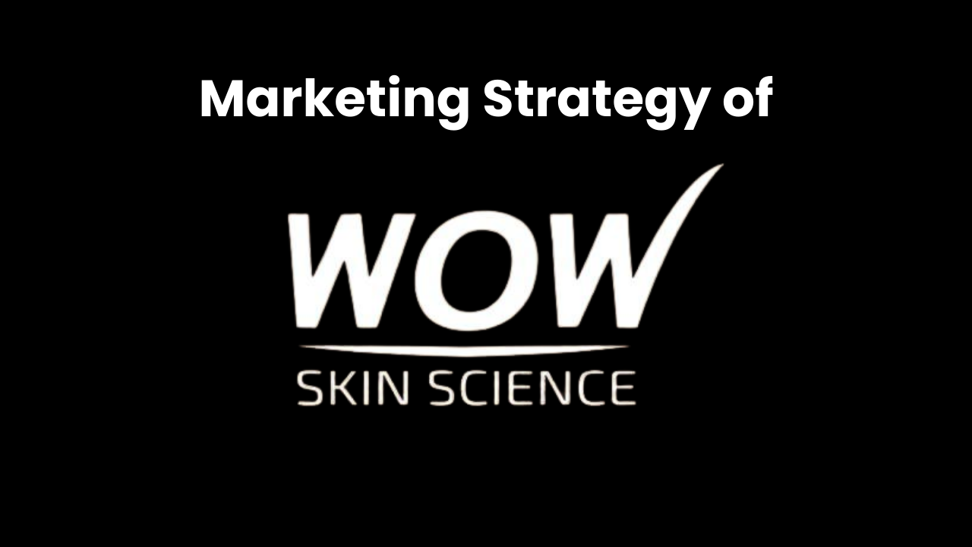

### ****1. Product Strategy (Product Differentiation & Positioning Theory)****

WOW Cosmetics focuses on **natural, chemical-free, and cruelty-free** beauty products, aligning with the **Brand Differentiation Strategy**. Their **Unique Selling Proposition (USP)** is based on the use of premium natural ingredients like **onion, apple cider vinegar, aloe vera, and vitamin C**, which cater to health-conscious consumers.

**2. Pricing Strategy (Value-Based & Competitive Pricing Theory)**

WOW Cosmetics follows a **value-based pricing strategy**, where the pricing reflects the **perceived benefits of natural and organic ingredients**. Their pricing is competitive in the premium haircare and skincare market, ensuring affordability while maintaining a high-quality standard. The brand also uses **penetration pricing** during new product launches and **bundle pricing** for combo packs to increase customer value.

**3. Distribution Strategy (Place – Omnichannel Marketing Approach)**

The brand follows the **Selective Distribution Model**, ensuring availability in **e-commerce platforms (Amazon, Flipkart, Nykaa, WOW’s official website), retail stores, supermarkets, and pharmacies**. This strategy enhances reach and convenience for customers.

**4. Promotion Strategy (Integrated Marketing Communication – IMC Theory)**

WOW Cosmetics uses a mix of **traditional and digital marketing** to reach its target audience effectively. Their strategy is based on the **AIDA Model (Attention, Interest, Desire, Action)** to attract, engage, and convert customers.

#### ****A. Digital Marketing (Pull Marketing & Social Media Influence Theory)****

#### ****B. Customer Retention (Relationship Marketing & Loyalty Programs)****

**5. Sustainability & Ethical Marketing (Green Marketing Theory)**

WOW Cosmetics integrates **sustainability and ethical marketing** as part of its branding strategy. By using **eco-friendly packaging, cruelty-free formulations, and sustainable ingredient sourcing**, the brand appeals to environmentally conscious consumers, aligning with the **Green Marketing Theory**. Campaigns promoting sustainable beauty practices further enhance WOW’s credibility

Post Creation of wow cosmetics

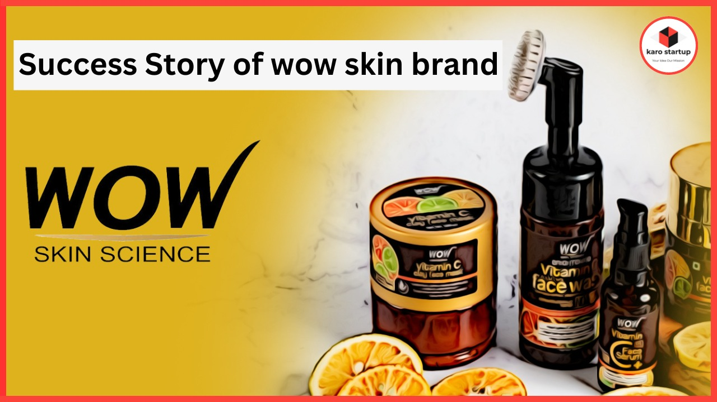

**Wow Skin Science Marketing Strategy and Case Study** – Every successful business has a story behind it – often full of hurdles, disappointments and failures. If you look closely, you will see that almost all businesses worth talking about have had their fair share of failures.

One such company – rather a brand – which too has risen from such failures is Wow Skin Science.

In this article, we will take a look at the success story and case study of Wow Skin Science, which has taken the skin and hair care segment of the nation by storm through its highly aggressive digital marketing strategies.

**Design/video editing**



**WOW Skin Science** can use video editing for several types of content to market their cosmetics and skincare products. Here are some ideas:

1. Product Showcases & Ads
2. Skincare Routine & Tutorials
3. Before & After Transformations
4. ASMR & Aesthetic Videos
5. Trendy Social Media Reels & Shorts
6. Ingredient & Science Breakdown

Social media ad campaigns of wow cosmetics

WOW Skin Science can leverage social media ad campaigns to increase brand awareness, drive sales, and engage customers through visually appealing and informative content. A product-focused campaign can highlight key features, such as natural ingredients and chemical-free formulations, using high-quality close-up shots, engaging text overlays, and fast-paced edits. Influencer and user-generated content (UGC) campaigns can build trust by featuring real people sharing their WOW experiences, showcasing skincare routines, or participating in viral challenges like the **#WOWGlowChallenge**, where users post before-and-after results . Trend-based campaigns on TikTok and Instagram Reels can use ASMR skincare videos or fun transitions to capture attention, while seasonal promotions can create urgency with limited-time discounts and festive themes. Additionally, testimonial-driven campaigns featuring dermatologist recommendations and customer reviews can establish credibility. By combining high-quality visuals, engaging storytelling, and strong call-to-action (CTA) messages like “Shop Now” or “Try WOW Today,” the brand can effectively connect with its audience and drive conversions across Instagram, Facebook, TikTok, and YouTube.



WOW Skin Science has successfully positioned itself as a trusted brand by offering natural, chemical-free, and effective skincare and haircare solutions. Through innovative social media ad campaigns, the brand can continue to engage a wide audience, build credibility with user-generated content and expert testimonials, and drive sales with visually compelling product showcases. By leveraging trends, influencer collaborations, and seasonal promotions, WOW can maintain its strong market presence and connect with consumers who seek clean, science-backed beauty solutions. With a focus on high-quality content, strong brand messaging, and interactive campaigns, WOW Cosmetics can continue to grow and inspire confidence in natural beauty worldwide.Top of Form

Bottom of Form